we will see how to identify the following form elements

* [Radio Button](https://www.guru99.com/checkbox-and-radio-button-webdriver.html#7)
* [Check Box](https://www.guru99.com/checkbox-and-radio-button-webdriver.html#8)

**Radio Button**

Radio Buttons too can be toggled on by using the click() method.

Using http://demo.guru99.com/test/radio.html for practice, see that radio1.click() toggles on the “Option1” radio button. radio2.click() toggles on the “Option2” radio button leaving the “Option1” unselected.

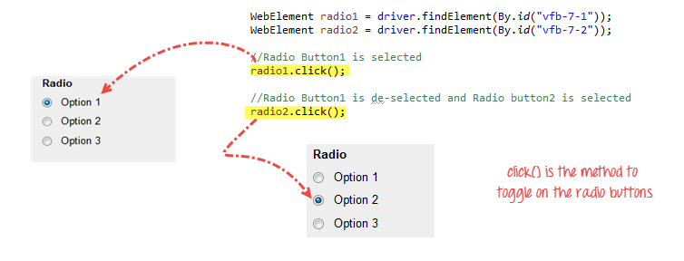

**Check Box**

Toggling a check box on/off is also done using the **click()** method.

The code below will click on Facebook’s “Keep me logged in” check box twice and then output the result as TRUE when it is toggled on, and FALSE if it is toggled off.

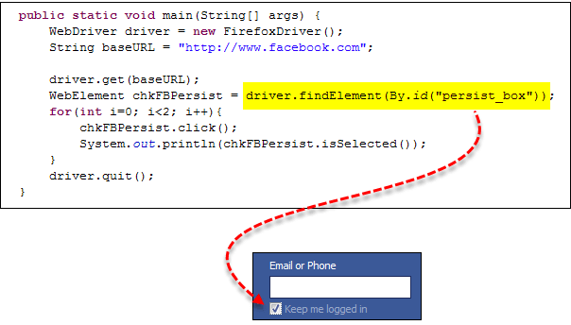

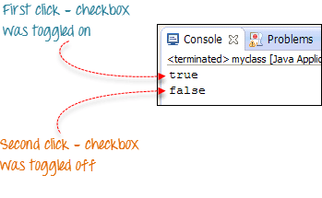

isSelected() method is used to know whether the Checkbox is toggled on or off.

Here is another example: http://demo.guru99.com/test/radio.html

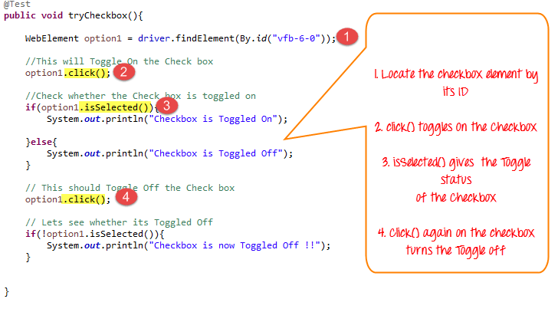

**Complete Code**

Here is the complete working code

import org.openqa.selenium.By;

import org.openqa.selenium.WebDriver;

import org.openqa.selenium.chrome.ChromeDriver;

import org.openqa.selenium.*;

public class Form {

public static void main(String[] args) {

// declaration and instantiation of objects/variables

System.setProperty("webdriver.chrome.driver","G:\\chromedriver.exe");

WebDriver driver = new ChromeDriver();

driver.get("http://demo.guru99.com/test/radio.html");

WebElement radio1 = driver.findElement(By.id("vfb-7-1"));

WebElement radio2 = driver.findElement(By.id("vfb-7-2"));

//Radio Button1 is selected

radio1.click();

System.out.println("Radio Button Option 1 Selected");

//Radio Button1 is de-selected and Radio Button2 is selected

radio2.click();

System.out.println("Radio Button Option 2 Selected");

// Selecting CheckBox

WebElement option1 = driver.findElement(By.id("vfb-6-0"));

// This will Toggle the Check box

option1.click();

// Check whether the Check box is toggled on

if (option1.isSelected()) {

System.out.println("Checkbox is Toggled On");

} else {

System.out.println("Checkbox is Toggled Off");

}

//Selecting Checkbox and using isSelected Method

driver.get("http://demo.guru99.com/test/facebook.html");

WebElement chkFBPersist = driver.findElement(By.id("persist_box"));

for (int i=0; i<2; i++) {

chkFBPersist.click ();

System.out.println("Facebook Persists Checkbox Status is - "+chkFBPersist.isSelected());

}

//driver.close();

}

}